

Curriculum Policy

Date: January 2026

To be read in conjunction with:
• Accessibility Plan
• Equal Opportunities Policy
• E-Safety Policy
• Special Educational Needs and Inclusion
• SMSC & British Values
• Assessment
• Teaching and Learning

Policy Number | 12.0
Review Date | January 2027
Owner | Jasmin Mirza

Document History

Version | Comments/amendments | Name | Date
1.0 | Version 1 | Jasmin Mirza | September 2025
2.0 | Version 2 | Jasmin Mirza | January 2026

Contents Page

Curriculum Policy Statement 3
Pre-Formal Pathway 3
Semi-Formal Pathway 7
Formal Pathway 11
Assessment Cycle 15
Communication 15
Therapies 17
Interventions 18
Education outside the classroom, including visits and visitors 19
Enrichment Curriculum 20
Social, Moral, Spiritual and Cultural Education and British Values 21

Curriculum Policy Statement
At Woodside Park School (WPS), our curriculum is designed to meet the diverse needs of autistic pupils within a structured, nurturing, and responsive learning environment. We recognise that every child has a unique profile of strengths and needs, and our teaching approaches therefore prioritise communication, emotional regulation, independence, and social understanding alongside academic progress.
Our practice is firmly grounded in trauma-informed principles, acknowledging the impact of past and ongoing experiences on pupils’ well-being, behaviour, and readiness to learn. We are committed to maintaining an environment that is safe, predictable, and supportive, enabling all learners to access learning with confidence and security.
The school’s approach is a Total Communication Approach that is further underpinned by the AAD framework (Ask, Accept, Develop) for autism:
- Ask pupils about their preferences, perspectives, and needs.
- Accept pupils for who they are, without seeking to change or diminish their autistic identity.
- Develop strategies collaboratively to support growth, learning, and personal development.
This ethos ensures that learners’ voices are heard, their identities respected, and their learning journeys co-constructed in partnership with them.
Our curriculum fosters meaningful engagement, a sense of belonging, and holistic development, equipping pupils with the skills they need to thrive both in school and in the wider community. By tailoring teaching strategies and pathways to the individual, we ensure that each pupil is supported to achieve their aspirations and potential.
While we are committed to high academic outcomes, we recognise that sustainable progress is only achievable when core developmental priorities are addressed first. These include supporting social, emotional, and mental health, building resilience, and fostering positive attitudes towards learning. Accordingly, our curriculum balances subject-specific learning with therapeutic and developmental approaches, ensuring that pupils have the foundations required to succeed.
We acknowledge that strict adherence to the National Curriculum Programmes of Study can reduce flexibility, limiting opportunities for therapeutic interventions and holistic approaches. At WPS, our policy seeks to address this by adopting a balanced model that maintains academic ambition while embedding therapeutic support throughout the curriculum. This integrated model reflects our conviction that academic excellence and therapeutic provision are not competing priorities, but complementary elements of an effective education. Through this approach, WPS ensures that the curriculum remains personalised, responsive, and inclusive, enabling every learner to make meaningful progress and to prepare successfully for life beyond school.

Our yearly overview is split into the following transdisciplinary themes:

Who we are: Understanding personal identity and community.
Where we are in place and time; Exploring historical and geographical contexts.
How we express ourselves: Developing communication and expression skills.
How the world works: Investigating the functioning of the world around us.
How we organise ourselves: Learning about organisations and governance.
Sharing the planet: Addressing global challenges and sustainability.

The themes encourage pupils to make connections and explore real world problems, fostering a holistic learning experience.

Pre-Formal Pathway
Learner Profile
Learners working within the pre-formal curriculum often have profound and multiple learning difficulties and complex needs. They are at the very earliest stages of communication, attention and interaction. These children may use a range of pre-intentional or emerging intentional behaviours to show preferences, make choices or respond to familiar people, often requiring staff to interpret subtle cues such as changes in facial expression, body movement, vocalisation or physiological responses.

Learners are developing skills in Social Communication by learning to engage with others through early turn-taking, shared attention and developing trust in relationships. In Emotional Regulation, they require high levels of adult support to maintain well-being, manage sensory input and remain available for learning. Through Transactional Supports, staff provide structured routines, consistent communication approaches, and multi-sensory experiences that create predictability and security.

Learners at this level often show fleeting attention and may explore their world through sensory means rather than symbolic play. Learning focuses on providing meaningful opportunities to engage with people and their environment, with an emphasis on establishing positive relationships, fostering curiosity, and developing the earliest skills in making things happen.

Although their learning journeys are highly individualised, the overarching aim is to maximise independence, however small the steps, by enabling learners to develop control, make choices, and experience a sense of agency within their environment.

A “no-demand” approach means initial acceptance of pupils not being required to comply until they show readiness, reducing pressure/demands; informal / learner-led curriculum where choice, autonomy and emotion regulation are central.

Intent
We provide a personalised curriculum that:
Ensures learning is holistic, with all parts of the curriculum interconnected;
Builds in sufficient time for learners to repeat, practise and consolidate skills;
Recognises learners’ need for consistency;
Develops learners’ levels of engagement by finding out what interests and motivates them;
Places learners’ targets at the centre of the curriculum with their interests as the teaching vehicle.
Some learners in this group are working beyond the pre-formal in specific areas and are supported to access a semi-formal curriculum in those areas.
Recognises learners’ need for different levels of sensory stimulation.

Implementation
Whole School Approach | Lessons | Curriculum Areas
We have common themes across the curriculum which aim to be interesting, engaging and appropriate for our learners and provide relevant learning contexts for them to grow. The topics we teach are the vehicle for new learning to take place and to enable learners to make progress. The pre-formal curriculum is, at its heart, a personalised learning journey for each learner. A “no-demand” approach means initial acceptance of pupils not being required to comply until they show readiness, reducing pressure/demands; informal / learner-led curriculum where choice, autonomy and emotion regulation are central. | We aim to build the early communication, social and emotional, and cognitive skills that are the foundation of learning. The curriculum acknowledges the importance of movement and play in a child’s development, and the need our learners have for sensory and multi-sensory approach to learning. To help achieve a learner’s full potential, our lessons are:  multi-sensory  tactile  experiential  stimulating  relevant  individualised  To aid communication in lessons, we use a wide range of communication methods. On the pre-formal curriculum you might see use of:  body movements  OGG’s sign supported system  facial expression  eye movements/tracking  mouthing  vocalisations  increased processing time  Intensive Interaction – reactive to proactive (reaching out) to interactive  sensory cues – smells, music of reference objects of reference with single word use photograph symbols | Our classes follow a half termly overarching transdisciplinary theme from the Long-Term Plan.  Areas include:  Communication and language  Maths  Understanding the world  Expressive arts and design  Social and emotional development  SMSC and British Values  Personal development to include food technology, offsite visits, visitors, turn taking skills, self care  Physical development (REAL P.E.)  Blank’s Level of Questioning is used to support children’s language development by ensuring that questions are pitched to the children at the correct level, which supports their understanding of the task.  Zones of Regulation  Together with our therapy team, building to provide learners the opportunity to make progress against their EHCP, learner-specific targets within the following 4 areas:  -Sensory and Physical  -Communication and Interaction  -Personal Development  -Cognition and Learning  We also use attention autism to help students focus, engage and communicate with others.  Enrichment and life skills and Preparation for Adulthood (PfA) are interwoven into the curriculum, through PD and EHCP targets.
In addition, some learners can access therapies or interventions as required in section F of their EHCP plan.

Assessment
Learner progress is assessed on an ongoing basis, with staff capturing evidence regularly using an interactive recording tool called Evidence for Learning (EfL). Evidence collected includes observations, photographs, videos and learners’ work.

Progress is assessed against learner-specific set targets taken from a bespoke framework consisting of ‘I can’ statements suitable for the pathway. Progress towards personal targets is reviewed at key points through the year, with new targets being set as appropriate in a cycle of ‘assess, plan, review, do’. Targets are set in the following areas: sensory and physical, communication and interaction, personal development, cognition and learning to support the learners work towards their long-term goals, as set in the EHCP SEND profiles. As a short-term target is met, a new target that will further them towards their overall, long-term goal will be set.

The Engagement Model is used to measure exploration, realisation, anticipation, persistence, and initiation. Effective use of the engagement model is based on regular observational assessment and reflective pedagogy. Assessments should be conducted by someone who knows the pupil well so that schools are able to identify existing educational barriers. Progress through each of the 5 areas of engagement should be measured by identifying how established the pupil is against each of the areas of engagement. This will differ for each pupil according to their profile of needs as set out in their EHCP). The model combines a formative and summative assessment approach. It should be used to assess pupils’ progress and development regularly throughout the year. This enables a continuous cycle of ‘assess, plan, do and review’ to take place, which enables the pupils’ achievements and progress to be measured over time.

Blank’s Level of Questioning is used to assess children’s language development.

Semi-Formal Pathway
Learner Profile
The semi-formal curriculum supports a wide range of learners typically working well below age related National Curriculum Levels.

Learners following the semi-formal curriculum generally have significant and complex learning needs, but they are beginning to develop more consistent skills in communication, interaction and independence. They may use a combination of emerging speech, vocalisations, signs, symbols, or augmentative and alternative communication (AAC) systems to express their needs, make choices and share experiences. These learners often show greater awareness of others and are beginning to form intentional social interactions, though they continue to require high levels of support to generalise skills across contexts.

Learners are working to extend their Social Communication by engaging in shared activities, developing functional communication, and participating in simple social exchanges with familiar adults and peers. In Emotional Regulation, they may be developing strategies to manage arousal levels, cope with changes, and recover from dysregulation with support. Through Transactional Supports, staff provide clear structure, visual and verbal cues, and consistent routines to help learners anticipate events, make connections, and succeed in a range of learning activities.
Learners at this level are often able to sustain attention for slightly longer periods, explore activities with more purpose, and participate in early problem-solving tasks. Play may be functional or emerging symbolic, and learners may begin to show preferences for particular peers, activities or themes.

The focus of learning is on building independence and transferable life skills, including communication, self-care, and making meaningful choices. Teaching approaches remain highly personalised, but learners are increasingly encouraged to take part in group activities, develop early academic concepts at their own pace, and apply their skills in everyday routines.

Intent
We provide a personalised curriculum that:
Promotes independence by developing skills that will allow learners to be as independent as possible;
Develops independence by providing explicit instructions and sufficient time for learners to repeat, practise, maintain and consolidate skills; Challenges and stretches learners with a strength in English and Maths to reach their full potential;
Develops learners’ levels of engagement by finding out what interests and motivates them;
Provides meaningful contexts for learning that use real-life materials and experiences, concrete resources and practical everyday activities so that learners link experiences and make connections;
Supports learners to develop an awareness of, and interest in, themselves and their immediate surroundings and environment;
Recognises the importance of play and games as motivational curriculum activities that allow repetition and consolidation of skills;
Recognises that when using imagination and thinking of something that is not immediately present, children with SLD may need prompts to recall an experience;
Includes activities that move beyond memory-building activities to take part in supported thinking and problem-solving activities;
Provides opportunities for generalising and applying skills and knowledge across curriculum areas;
Acknowledges that the physical wellbeing and development of our SLD learners is important;
Recognises some of our learners may not be physically able to complete practical processes without full support, but that they should be involved in choice and decision-making about the process.

Implementation
Whole School Approach | Lessons | Curriculum Areas
We have common themes in place across the curriculum, which aim to be interesting, engaging and appropriate for our learners and that provide relevant learning contexts for them to grow. The topics we teach are the vehicle for new learning to take place and to enable learners to make progress. | On this pathway we aim to minimise the learning barriers experienced by individual learners. We aim to equip our learners with the skills, knowledge and passion to participate and contribute within society, empowering them to live active and fulfilled lives.  It is essential that learning is purposeful, immersive, fun and interactive; therefore, our lessons include: collaborative learning; active learning; multi-sensory activities; adaptive teaching; individualisation.  To aid communication in lessons, we use a wide range of communication methods. On the semi-formal curriculum you might see use of: photo support visuals  visual symbols  Now and Next prompts  OFG’s sign supported system  Visual timetable  Talk mats  Social stories  Verbal communication  Key word language | Our classes follow a half termly overarching transdisciplinary theme from the Long-Term Plan. Kapow is used as a knowledge source.  Language  Blank’s Level of Questioning is used to support children’s language development by ensuring that questions are pitched to the children at the correct level, which supports their understanding of the task.  Little Wandle Phonics and Early Reading.  Early Literacy - Literacy Shed  Rennaissance: Accelerated Reader, Star English  Early Numeracy - WhiteRose Maths, Star Maths  Zones of Regulation  Enrichment and life skills and Preparation for Adulthood (PfA) interwoven into the curriculum, through PD and EHCP targets.  Together with our therapy team, building to provide learners the opportunity to make progress against their EHCP, learner-specific targets within the following 4 areas:  -Sensory and Physical  -Communication and Interaction  -Personal Development  -Cognition and Learning
In addition, some learners can access therapies or interventions as required in section F of their EHCP plan.

Assessment
Learner progress against EHCP targets are assessed on an ongoing basis with staff capturing evidence regularly using an interactive recording tool called Evidence for Learning (EfL). Evidence collected includes observations, photographs, videos and learners’ work.

Progress is assessed against learner-specific set targets taken from a bespoke framework consisting of ‘I can’ statements suitable for the pathway. Progress towards personal targets is reviewed at key points through the year, with new targets being set as appropriate in a cycle of ‘assess, plan, do, review’. Targets are set in the following areas: sensory and physical, communication and interaction, personal development, cognition and learning to support the learners work towards their long-term goals, as set in the EHCP SEND profiles. As a short-term target is met, a new target that will further them towards their overall, long-term goal will be set.

Progress is assessed against subject specific targets taken from the National Curriculum. Pre-key stage standards focusing on key aspects of English reading, English writing and Mathematics are also used. Assessments are recorded on subject specific assessment trackers.

Little Wandle is used to assess phonics using the assessment tracker. Reception and Year 1 level reading targets are assessed half termly using the reading assessments.

Beyond Year 1, reading (Star English) is assessed using Accelerated Reader on Renaissance. All students are screened once per term. (Weekly AR diagnostic reports are used to plan weekly instruction and intervention for each class.)

Blank’s Level of Questioning is used to assess children’s language development.

Mathematics is assessed using WhiteRose end of unit assessments and termly using Star Maths, also placed on assessment tracker.

Formal Pathway
Learner Profile
Learners on our formal curriculum have moderate learning difficulties, alongside associated complexities, such as SEMH, physical and visual impairments. Learners access a range of National Curriculum subjects for their Key Stage woven into a topic under a transdiciplinary theme, to ensure a holistic approach, promote repetition and engagement. It is modified to accommodate their developmental level and special educational needs. Life skills and independence skills also form a part of the curriculum, in addition to the more traditional formal learning subjects. As the term ‘formal’ implies, there is a high level of structure. We nevertheless avoid making the formal curriculum too abstract; teachers ensure that learning is linked to practical activities and consolidated and applied in practical sessions.

Intent
We provide a curriculum that: is primarily accessible to those learners’ with moderate learning difficulties in their learner profile; supports learners to develop their interests as well as their skills and knowledge; is a planned programme of objectives, content, learning experiences, resources and assessment based on, but not exclusive to, the National Curriculum 2014; includes life skills and independence skills; ensures learning is linked to practical activities and consolidated and applied in practical sessions; is interconnected to encourage the transference of skills and knowledge across the learning pathway, whilst allowing for subject-specific knowledge and understanding to be embedded; recognises some of our learners may not be physically able to complete practical processes without additional support, but that they should be involved in choice and decision-making about the process; through collaboration with a range of other professionals, is accessible to all learners as part of a bespoke provision of supported access and personalised approaches e.g. SaLT input in supporting non-verbal learners to use AAC devices to communicate about their learning.

Implementation
Whole School Approach | Lessons | Curriculum Areas
We have common themes in place across the curriculum, which aim to be interesting, engaging and appropriate for our learners and that provide relevant learning contexts for the students to grow. Formal learners follow a modified National Curriculum across Key Stages 1and 2. | On our formal pathway, we teach a range of subjects to enable the learner to become an active and engaged contributor to society. Our lessons include: subject specific learning, collaborative learning, active learning, adaptive teaching, individualisation.  To aid communication in lessons, we use a wide range of communication methods: visual symbols, OFG’s sign supported system, visual timetables, verbal communication, written language. | Our classes follow a half termly overarching transdisciplinary theme from the relevant Key Stage Long Term Plan. Kapow is used as a knowledge source.  Key Stage 2  National Curriculum/Kapow used as a knowledge source for: Science, History, Geography, Art and Design, Design and Technology, Music, Computing, RSE/PSHE  National Curriculum: English, Maths,  English  Literacy Shed  Rennaissance: Accelerated Reader, Star English  Maths  WhiteRose Maths  Renaissance – Star Maths  PE – REAL P.E.  Zones of Regulation  Together with our therapy team, building to provide learners the opportunity to make progress against their EHCP, learner-specific targets within the following 4 areas:  -Sensory and Physical  -Communication and Interaction  -Personal Development  -Cognition and Learning  Enrichment and life skills and Preparation for Adulthood (PfA) interwoven into the curriculum, through PD and EHCP targets.
In addition, some learners can access therapies or interventions as required in section F of their EHCP plan.

Assessment
Progress is assessed against subject specific targets taken from the National Curriculum.

All subjects (English, Maths, Science, Humanities, PE, Music, Art, DT, ICT, PSHE, RSE) are assessed against the National Curriculum framework and placed on an assessment tracker. Mathematics is assessed using WhiteRose end of unit assessments and termly using Star Maths. Science, History, Geography, Art and Design, Design and Technology, Music, Computing, RSE/PSHE objectives are assessed using end of unit assessments on Kapow.

Literacy is assessed using the Literacy Shed end of unit assessments.
Reading (Star English) is assessed using Accelerated Reader on Renaissance. All students are screened once per term. (Weekly AR diagnostic reports are used to plan weekly instruction and intervention for each class.)

Blank’s Level of Questioning is used to assess children’s language development.

Progress towards personal targets is reviewed at key points through the year, with new targets being set as appropriate in a cycle of ‘assess, plan, review, do’. Targets are set in the following areas: sensory and physical, communication and interaction, personal development, cognition and learning to support the learners work towards their long-term goals, as set in the EHCP SEND profiles. As a short-term target is met, a new target that will further them towards their overall, long-term goal will be set. Learner progress is assessed on an ongoing basis, with staff capturing evidence regularly using an interactive recording tool called Evidence for Learning (EfL). Evidence collected includes observations, photographs, videos and learners’ work.

Assessment Cycle
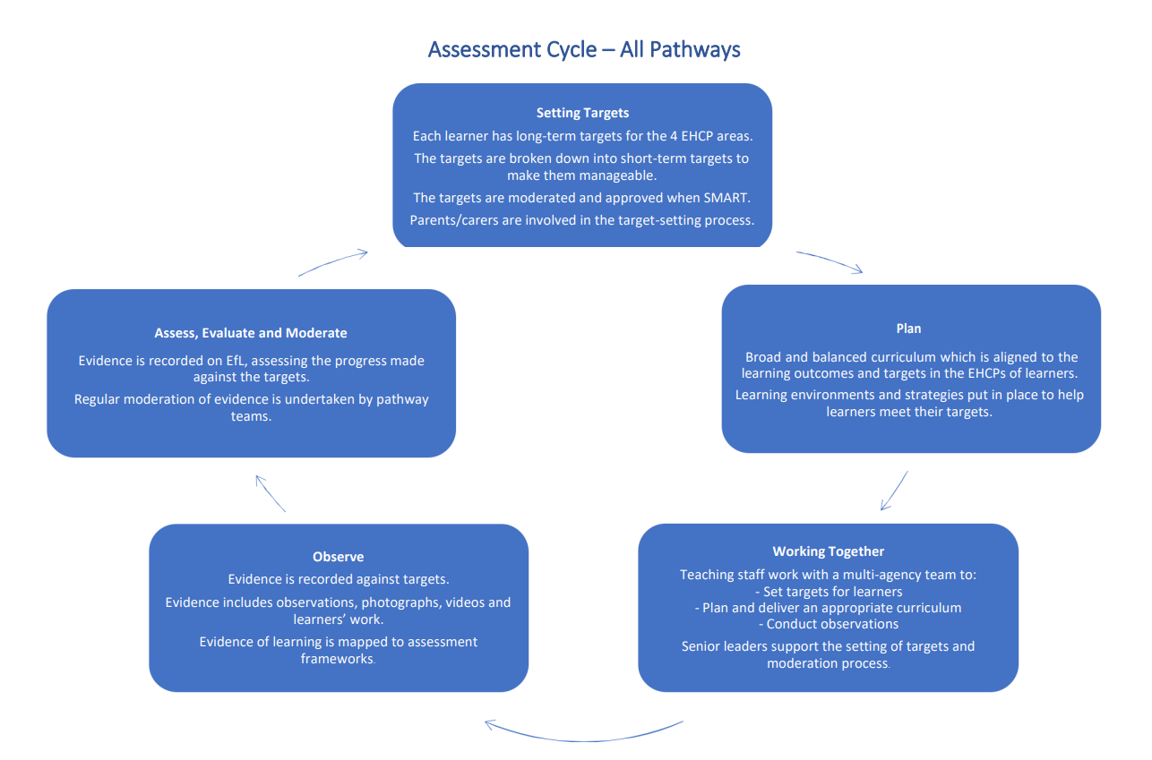

Communication
Communication
We offer a Total Communication approach. The main focus of the total communication approach is to explore different ways for the individual to communicate as effectively as possible. Total communication also focuses on increasing an individual’s functional communication (communication used in everyday life).

We use AAC (Augmentative and Alternative Communication) designed to support or replace spoken communication for individuals.

Intensive Interaction is a person-centred communication approach we use that directly improves social inclusion and communication. It is a responsive approach which values each individual’s uniqueness, with practitioners consciously adjusting their communicative style to facilitate mutual connection.

At Woodside Park you may see the use of gesture, facial expression, props, objects of reference, communication boards, visuals, (photo support, Now/Next boards, timetables) visuals, Widgit symbols, communication cards, OFG’s sign supported system, writing, drawing, Talk Mats, social stories, verbal communication, key word language.

Learner need defines the communication support offered to each learner.

Communication support also differs across our different pathways and is highlighted in the communication flowchart. This flowchart highlights some of the communication methods we might also expect to see across the different curriculum pathways. We work closely with our Speech and Language therapist to incorporate individual learner programmes into the school day.

Communication Flowchart
Pre Formal | Semi Formal | Formal
Body movements  Signs  Facial expression  Eye movements  Mouthing  Vocalisation  Increased processing time  Intensive Interaction  Sensory cues – smells, music of reference  Objects of reference with single word use  Photograph symbols  Sensory regulation/Sensory diet  Communication cards  Songs of reference for transition  Social Stories  Sensory Stories  AAC  Key word language  OFG’s sign supported system | Photo support visuals  Visual symbols  Now/Next  Visual Timetable  Talk Mats  PECS (adapted)  Social Stories  Verbal Communication  Key word language  OFG’s sign supported system | Visual symbols  Visual timetable  Verbal communication  Written language  OFG’s sign supported system

Therapies
Therapies
The school recognises that some learners have additional needs, as identified in their Education, Health and Care Plan (EHCP), which require support from specialist therapists. To ensure these needs are addressed, a range of professionals form part of the Clinical Team. They work collaboratively with class teams and parents, either by developing individualised therapy plans or by supporting the delivery of therapeutic programmes within the classroom. The nature and level of therapy support is determined on an individual basis, informed by assessment and ongoing dialogue with the multidisciplinary team around the learner.
Where appropriate, learners may also access NHS therapy services, including Speech and Language Therapy, Occupational Therapy, and Physiotherapy. Therapists support learners’ development in a number of ways, including:
- Training and equipping education staff with strategies to embed therapy into daily learning opportunities;
- Working in partnership with the education team to establish a holistic understanding of learners’ skills and how these impact on their learning, behaviour, and social development;
- Delivering targeted interventions and direct therapy where required;
- Contributing to a child-centred approach in which therapy is fully integrated into the wider educational experience.
The Pyramids of Learning
The Pyramids of Learning that follow show the steps and stages required to achieve academic learning and efficient communication skills. At Woodside Park School, we understand that a child’s development happens from the bottom of the pyramid up.
Our teachers and therapists focus on securing skills at the bottom of the pyramids so that the next stage of learning is built on strong foundations. This makes sure that your child’s progress is not lost, and that they can use their skills in their everyday life.

Interventions
Interventions
Social, Emotional, Mental Health (SEMH)

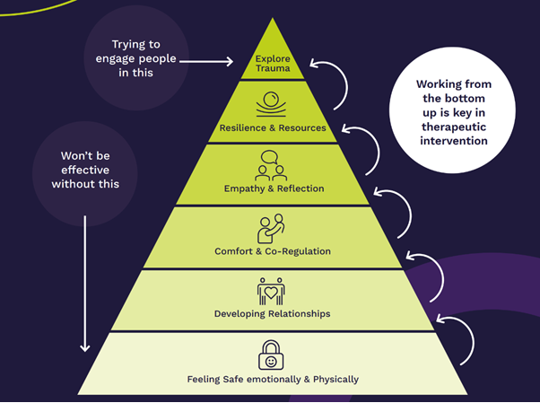

Emotional Health and Wellbeing
The clinical team work to support individuals who may have experienced or be experiencing pressures that impact on their emotional health and wellbeing and therefore impacting on their daily functioning. The clinical team makes use of methods such as: Positive Behaviour Support, Functional Behaviour Assessment (Behavioural Analysis), Emotional Regulation and Mental Health Support, Play Therapy and Sensory Massage.
Sensory and Physical:

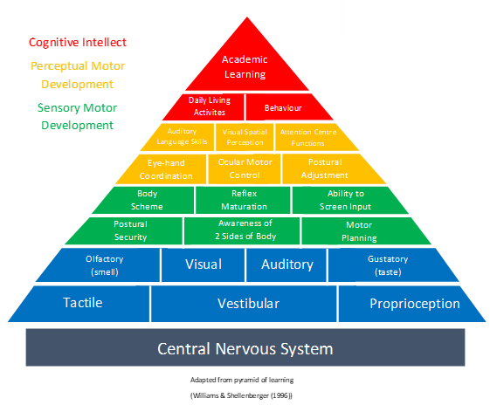

Sensory Circuits
Sensory Circuit interventions are available for those learners who need help settling into their school day. The aim of the Sensory Circuits programme is to facilitate sensory processing and sensory integration, and to allow learners to be in the optimum state of alertness, ready for learning. The children participate in a short 10–15-minute session of activities designed to improve brain processing efficiency, and they generally find that the circuit is a fun way to start the day. Sessions are run in the morning before learners attend their first lesson.

Sensory Diets Identified learners have a sensory diet, a programme of sensory activities that are specifically scheduled into their day to ensure they’re getting the input their bodies need. The sensory diets assist with attention, arousal and adaptive responses.

Zones of Regulation
We recognise the importance of promoting positive mental health and emotional wellbeing in our learners and their families. We aim to create an open culture around the discussion of mental health and wellbeing and to empower our children be able to regulate their emotions. By implementing the Zones of Regulation curriculum we aim to teach our learners to identify emotions in themselves and others and provide them with a bank of strategies to help regulate their emotions and improve their wellbeing. Zones of Regulation is a curriculum based around the use of four colours to help children self-identify how they’re feeling and categorise it based on colour. The curriculum also helps children better understand their emotions, sensory needs and thinking patterns. The children learn different strategies to cope and manage their emotions based on which colour zone they’re in. Additionally, Zones of Regulation helps children to recognise their own triggers, learn to read facial expressions, develop problem-solving skills, and become more attuned to how their actions affect other people.

Speech, Language and Communication:
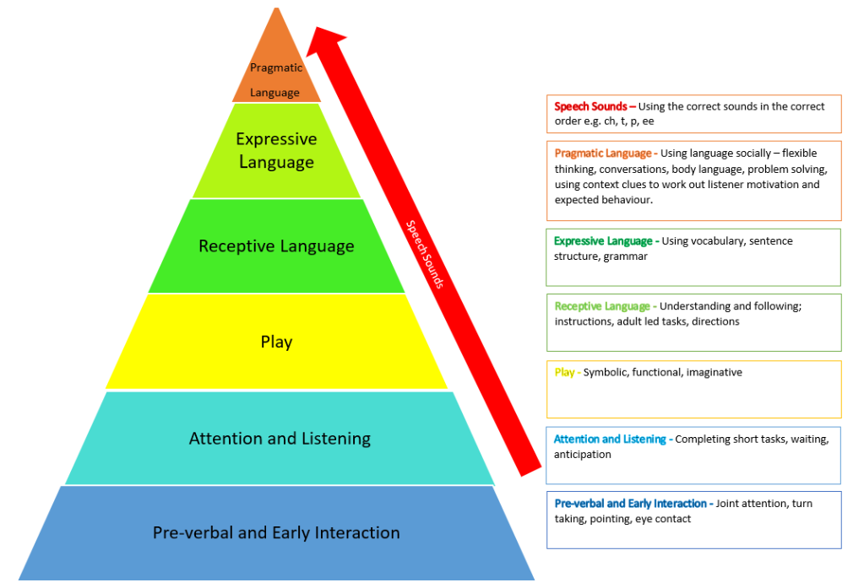

Education outside the classroom, including visits and visitors
Education outside the classroom, including visits and visitors
Educational visits and external visitors to school play a significant part in our curriculum offer. We believe our learners learn best through experience and therefore we aim for all learners to engage in learning outside the classroom. These experiences are often linked to curriculum topics; however, they can be standalone events. Examples are: visits/assemblies by community police and fire service; offsite PE activities including swimming; theatre and musical trips; museums; places of worship; parks; supermarkets and sensory play.

Enrichment Curriculum
Education outside the classroom, including visits and visitors
The enrichment curriculum provides learners with opportunities to acquire life-long skills and interests that promote independence, self-confidence, and preparation for adult life. It is intended to develop individual skills and talents through practical and experiential approaches to learning.
Enrichment is delivered both within the classroom and across the wider curriculum, as well as through external opportunities such as educational visits and contributions from visitors.
Furthermore, a dedicated afternoon each week is allocated to enrichment activities. These sessions are designed to promote cognitive and academic growth, personal and social development, increased engagement with school life, and the advancement of equity and inclusion. Learners are able to select from a range of clubs and activities, which may include:
- Dance
- Signing Choir
- Board and card games
- Football
- Gardening Club
- Computers
- Lego/Construction Club
- Arts and Crafts

Social, Moral, Spiritual and Cultural Education and British Values
Education outside the classroom, including visits and visitors
We recognise that social, moral, spiritual and cultural education (SMSC) including British values plays a significant part in the personal development of our learners. SMSC is a dimension of the whole school experience which makes the curriculum relevant, creative, stimulating and fun. It enriches the curriculum and ethos of our school.

Impact
Case studies, Evidence for Learning and SEND Profiles demonstrate that learners achieve their short- and long-term personalised outcomes, and that they access our rich and ambitious curriculum and fulfil their potential. Learners are well prepared to transition at each stage of their education, showing that the curriculum supports them to move on appropriately at each step.



